Dashboard Design

Date | 23 July 2026
Team ID | Khushi Bhatia
Project Name | Food Ordering Behaviour and Consumer Trends: A Structured Analysis of Choices and Habits
Maximum Marks | 5 Marks

Activity 1: Interactive and Visually Appealing Dashboards

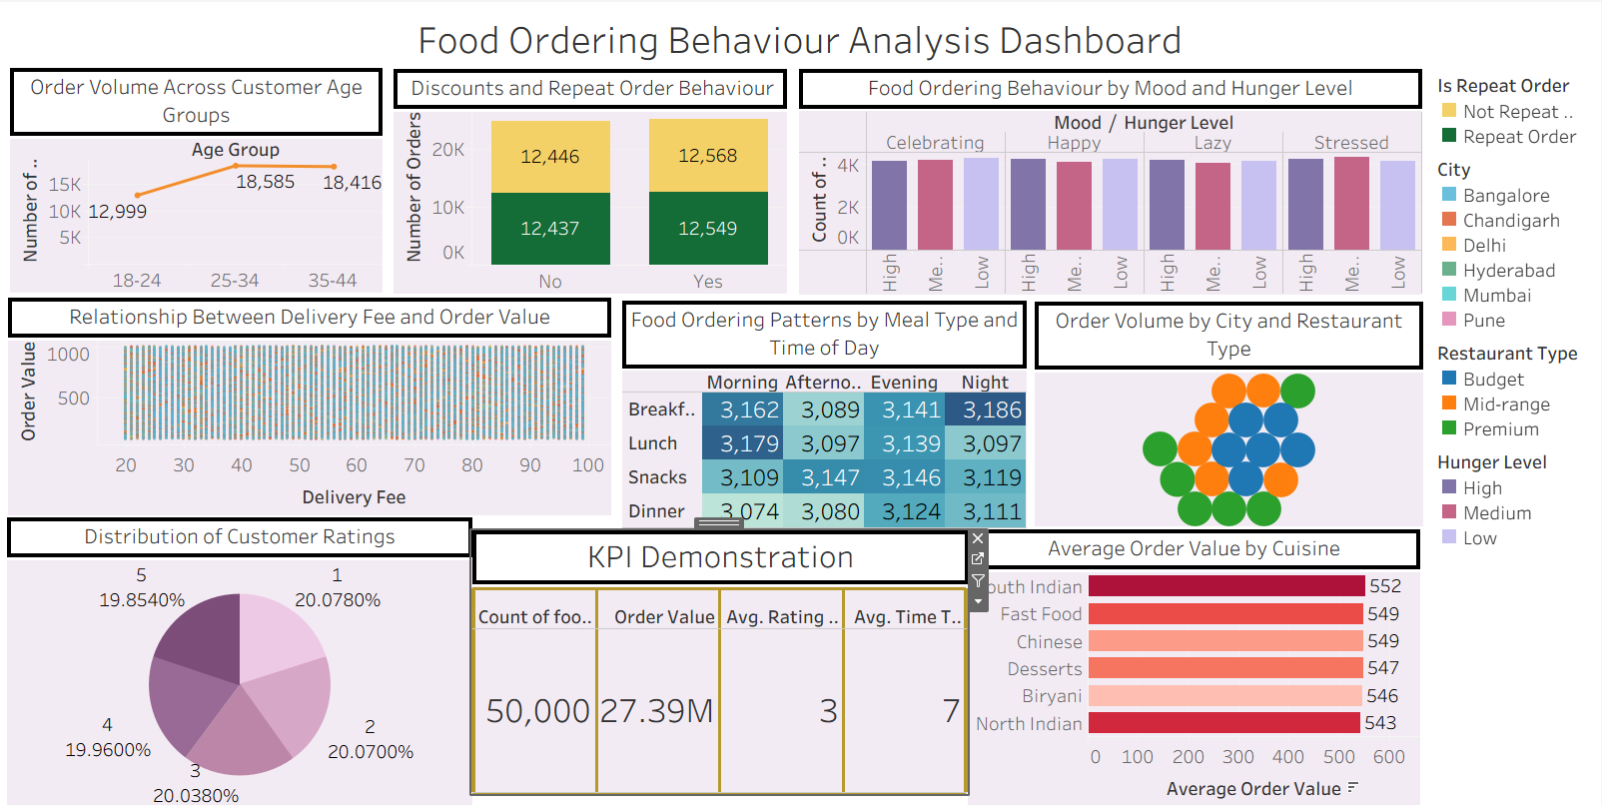

The dashboard was designed using a clear and intuitive layout with consistent colors, KPI cards, and interactive visualizations. It provides an overview of customer ordering behaviour and helps users explore trends efficiently.
- Customer Age Group Analysis (Q1): The line chart highlights order volume across different age groups, helping identify the most active customer segment.
- Cuisine Preference Analysis (Q2): The bar chart compares average order values for different cuisines, enabling businesses to identify high-value food categories.
- Discount and Repeat Order Analysis (Q3): The stacked bar chart shows the relationship between discounts and repeat orders, helping evaluate promotional strategies.
- Meal Type and Order Time Analysis (Q4): The heatmap displays ordering patterns across meal types and times of the day, helping businesses understand peak demand periods.
- Delivery Fee vs Order Value (Q5): The scatter plot illustrates the relationship between delivery charges and order value, supporting pricing and delivery decisions.
- Customer Rating Distribution (Q6): The pie chart summarizes customer ratings, providing an overview of customer satisfaction levels.
- City and Restaurant Type Analysis (Q7): The bubble chart compares order volume across cities and restaurant types, helping identify high-performing markets.
- Mood and Hunger Level Analysis (Q8): The side-by-side bar chart shows how customer mood and hunger level influence food ordering behaviour.
- Interactive Dashboard Features: Filters and interactive elements allow users to explore data by customer attributes, cuisines, cities, meal types, and other variables for deeper business insights.

Activity 2: Live Deployment Link
Below is the verified public access link to the interactive, cloud-hosted visualization story:
Tableau Public Dashboard Link:
Food Ordering Behaviour Analysis | Tableau Public https://public.tableau.com/views/FoodOrderingBehaviourAnalysis_17847483319120/Dashboard?:language=en-US&:sid=&:redirect=auth&:display_count=n&:origin=viz_share_link

